Issue #57
16-31st Dec‘23

TAFI NJC meeting was held on 8th Dec 2023 at Muscat, Oman
TAFI National Joint Council Meeting was held on 8th Dec 2023 at Radisson Hotel, Muscat, OMAN. TAFI Managing Committee and Chairpersons from all regions and chapters across India form the National Joint Council. The NJC had the meeting of its newly elected office bearers in Muscat , Oman supported by Oman Air. It was an orientation for the new office bearers with special focus on the core industry issues and enhanced value addition measures for our membership. The team of 24 delegates flew from various cities into Muscat on 7th Dec. The meeting was held on 8th Morning 9 am through 4 pm with short tea and Lunch Break. It was a very interactive session and productive one. This visit also gave us an opportunity to experience Oman, a Gulf Nation with happy people and fly Oman Air.

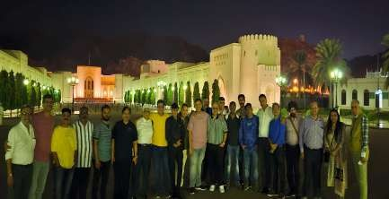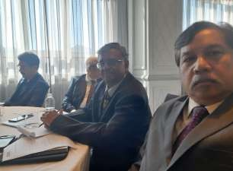

Page 1

Issue #57
16-31st Dec‘23

TAFI TN felicitated Consul General Of Malaysia at Chennai on 11 Dec
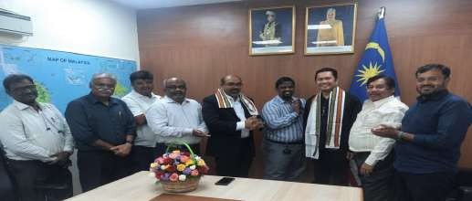
As per the decision taken in the NJC meeting on 8 Dec ‘23, TAFI TN visited the office of the Consul General of Malaysia at 2:30 pm on 11th Dec ’23. We were warmly welcomed by Consul General Mr. Saravanafiumar, who engaged in a productive discussion with us regarding Visa Free entry to Malaysia. Mr. Saravanakumar clarified various points raised by us, and we also had the pleasure of the presence of Tourism Malaysia Director Mr. Razaidi during the felicitation.

TN Team met Dy. High Commissioner of Srilanka at Chennai
Tamilnadu Chapter visited Dy. High Commissioner of Srilanfia Dr. Venfiateswaran at his office on 11th Dec 2023 and felicitated and thanked the Srilankan Govt decision of Visa Fee waiver for Indian Tourists. The Chapter Chairman,Mr. Jahir Hussain, National Management Committee Member Mr. Anandaveloo, Chapter Treasurer, Mr. Raju Varghese, Committee Member, Mr. Amjad Khan, Immediate Past Secretary Mr. Gofiularamanan, Past Treasurer Mr. Babu Kannappan and Past Secretary Mr. Bright Manohar were welcomed by the Dr. Venkateswaran and the team felicitated him with a Bouquet and shawl for his Govt. Decision to waive Visa Fee for Indian Passport Holders. Dr. Venkateswaran requested the TAFI team to explore Eastern Srilanka and to promote the same to the Indian Visitors.

TAFI TN visited Thai Consulate at Chennai on 14 Dec 23
The Tamil Nadu Team visited the Thai Consulate at Chennai to Greet and felicitate the Consul General for his Govt decision for Visa free entry for Indians to Thailand. Deputy Consul General Ms. Pornpan Janfirajang and The Visa Consul Mr. Pinpong Chauvachata along with her accorded warm welcome to the Tamil Nadu Team comprising Mr. Anandaveloo, National Management Committee Member Chapter Secretary Mr. C.K. Raja. Chapter Treasurer Mr. Raju Varghese and Past Secretary Mr. Gofiularamanan. It was a very cordial meeting & the Consul requested to promote Thailand as the favourite destination for Indians.

Page 2

Issue #57
16-31st Dec‘23

Indonesia mulls visa free entry for 20 countries
Indonesia’s Tourism Minister Sandiaga Uno is in talks with immigration officials with a goal of waiving fees for travellers of 20 countries. These include top source markets including Australia, China, India, the US, UK, France and five Middle East nations. “In the next month, it will be finalised, and after that, we will receive direction from the president, and the policy will be followed up with
immigration,” Sandiago said. If all goes to plan it could be implemented in early 2024. He didn’t say if the proposed tourist tax for Bali would be affected by this. When visa free entry was last available a few years ago, the number of Australians holidaying in Bali rose 16%. Nationals of nine neighbouring ASEAN member countries currently have visa free visits to Indonesia. These include Malaysia, Thailand, Singapore and Vietnam.

Malaysia Airlines’ tax-free shopping loyalty perk
Enrich has entered into a partnership with travel tech company utu to provide members with up to 40% additional Enrich Points through tax refunds on purchases made during international travel. Through utu, shoppers can now receive the equivalent of up to USD140 in Enrich points for every USD100 in value-added tax (VAT) refunds. The refunds are delivered in the form of extra
Enrich Points.These points can be redeemed for additional travel and lifestyle privileges at home and abroad. Philip See, CEO of Loyalty & Travel Services (MAG), said: “The partnership with utu enhances the travel experience for our valued Enrich members.” Enrich members can begin claiming points by downloading the utu app, where they will receive a digital utu Tax Free Card within the app. Members can choose to fill in their utu Tax Free Card number on any provided tax-free form or digital refund app and complete the standard Tax Refund Validation Process at the airport. Once this process is completed, the upsized value of the refund in Enrich Points is credited to their Enrich account. Asad Jumabhoy, CEO of utu said: “By partnering with utu, Malaysia Airlines is delivering exceptional value for all its Enrich Members.

VFS Global bags global contract to deliver UK visa, passport services to 142 countries
VFS Global has won the global contract for overseas UK visa and Citizenship (VCAS) Centres for the UK in 142 countries across Africa & Middle East, Americas, Australasia & Europe, China & Taiwan and Asia & Asia Pacific regions. These centres will accept all categories of visa applications as well as UK passport applications in some locations. Combined, these new centres are estimated to
process 3.8 million applicants every year, VFS shared. Beyond the scale of the deployment, VFS Global will also invest to improve the customer journey and increase accessibility, including through new customer websites, and through updated in-person experiences. It will also deploy its latest technologies to maintain robust identity checks and ensure the integrity of the visa and passport application process, VFS said. “We are delighted to win this contract and expand our partnership with the Home Office to become their service provider for all UK visa customers overseas. We are excited to begin operations in new locations, and to take the next step towards providing customers with a seamless, simple and secure visa and passport application experience,” said Zubin Karfiaria, Founder and CEO, VFS Global. “This win is a testament to our dedicated efforts to provide all our client Govts.

Page 3

Issue #57
16-31st Dec‘23

India's air passenger traﬃc to be 42 crore by 2030: Scindia
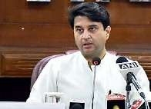
"The air passenger traffic, which is 14.5 crore today, will grow to 42 crores by 2030 and civil aviation will become a foundation for transportation in the country," he said after laying the foundation for a new terminal building at Rajahmundry Airport. Scindia also stated that the capacity at six metro airports (Bengaluru, Delhi, Chennai, Kolfiata, Mumbai and Hyderabad) which is 22 crore now, will go up to 42 crore in next five years. The minister said during the last nine years, 12 new
greenfield airports were added, taking the total number to 15. Next year, two new greenfield airports will be ready - one at Jewar next to Delhi and another in Navi Mumbai. Scindia said the total number of airports, waterdromes and heliports will go up from 149 to 220 by 2030. He mentioned that since Independence, the country had developed only 74 airports but in the last nine years it added another 75 airports, waterdromes, and heliports. A total of 32 routes were operationalised under the UDAN scheme in Andhra Pradesh. Rajahmundry, which had only one connection in 2014, today has connectivity to three cities. Tirupati is today connected to 10 cities in the country, against just one in 2014. Vijayawada, which was connected to only Hyderabad and Bengaluru, is connected to eight cities in India and also Sharjah. Visakhapatnam airport, which was connected to only nine cities in the country, is today connected to 14 cities and to Singapore. Kadapa airport, which was not in existence, is connected to four cities while Kurnool airport is connected to three cities. To be built at a cost of INR 350 crore, the new terminal at Rajahmundry Airport will have an area of 17,029 square metres, which will be four times the size of the existing terminal. It will also serve over 2,100 passengers during peak hours and 30 lakh passengers annually, which is nine times more than the current capacity of the terminal. He noted that Rajahmundry has been the centre of heritage, culture & tradition for time immemorial and birth place of Telugu language. On Rajahmundry MP Bharat Margani's demand for building a cargo terminal, he said once the new passenger terminal is built, the airport will get larger narrow-bodied aircraft. "If there is demand for seafood and plantations for domestic trade, we will think of setting up a cargo terminal," he added.

Saudia Private launches Robotic Process Automation
As part of its efforts to reimagine customer experience and achieve operational excellence, Saudia Private has announced a digital transformation strategy encompassing a range of technological advancements, including the soft launch of Robotic Process Automation (RPA). The announcement was made by Saudia Private at the Dubai Airshow 2023. The company also announced a number of
initiatives such as a new dynamic website featuring AI chatbots and a membership program. Its new website aims to ensure an enriched user experience with features such as online quote requests, a cost estimator, and other services. Additionally, an exclusive mobile application has been developed to enhance members’ experiences, it shared. The adoption of RPA does not only automate routine tasks but also elevates user’s experiences and helps sustainably manage seasonal and high-volume operations, the company said. “Innovation is critical in positioning Saudia Private as a leader in the aviation industry and a key driver of the Kingdom’s Vision 2030. Our digital transformation program is highly ambitious, as demonstrated by the scale of our investments and the quality of the initiatives we have implemented. We aim to become an international benchmark for technical advancements in the aviation industry and are relentlessly working towards excellence,” said Dr. Fahad Aljarboa, CEO, Saudia Private. “Incorporating RPA aligns perfectly with our broader digital transformation goals. This technology allows us to manage complex events and market disruptions with unparalleled efficiency.

Page 4

Issue #57
16-31st Dec‘23

Iran, Saudi Arabia to negotiate on direct scheduled ﬂights
Iran and Saudi Arabia will start formal talks next week to resume direct scheduled flights between Tehran and Riyadh and other cities, an Iranian official told the state-affiliated news agency ILNA on Sunday. Regular flights would be another step towards restoring ties between the two Middle Eastern rivals. "There are no restrictions regarding the launch of direct flights from Tehran to Riyadh, or other cities," Deputy Minister of Roads and Urban Development Mohammad Mohammadi
Bafihsh said, according to ILNA. "A bilateral working group will start final negotiations next week to have non-haj flights between the two countries," he said, referring to the annual Muslim pilgrimage to the holy city of Mecca in Saudi Arabia. Shi'ite-dominated Iran and Sunni Gulf monarchy Saudi Arabia cut ties in 2016 over Saudi Arabia's execution of a Shi'ite Muslim cleric and the subsequent storming of Riyadh's embassy in Tehran. There have been no regular direct flights between the two countries for years. Currently, only occasional direct flights take off from Iran carrying Haj Pilgrims. Mohammadibakhsh said a resumption of flights would include travel for pilgrims of the year-round Umrah - which can be undertaken at any time year - and also non-religious travel. Iran had already presented a list of airline companies which might operate flights, he said, but did not specify any. The Saudi Arabian government did not immediately respond to a request for comment.

Kenya to be a visa-free country for all tourists from January 24
Kenya has announced that it will abolish visa requirements for all global visitors beginning January 2024. This decision, announced by President William Ruto, is rooted in the country's commitment to embracing globalisation and opening its borders to drive socio-economic development. "Beginning January 2024, Kenya will be a visa-free country. It shall no longer be necessary for any person from any corner of the globe to carry the burden of applying for a visa to come to Kenya," Ruto said. To implement this policy, a
digital platform has been developed to identify all travellers to Kenya in advance through an electronic system. Once identified, visitors will obtain an electronic travel authorization, streamlining the entry process. President Ruto, a vocal advocate for a borderless Africa and visa-free travel, conveyed a simple message to the world: "To echo the call of the Turkana people to the world: 'Tobong’u Lorre!' a

Singapore Tourism Board names Markus Tan as Regional Director
The Singapore Tourism Board announces the appointment of Mr. Marfius Tan as the Regional Director for India, Middle East, South Asia, and Africa (IMESA), effective January 1, 2024. In his new role, based in Mumbai, Mr. Tan will spearhead STB’s initiatives in promoting Leisure and Business Travel & Meetings, Incentives, Conventions, and Exhibitions (BTMICE) in the IMESA region. His responsibilities will include overseeing travel promotions, public relations, and marketing, and driving developmental efforts to enhance Singapore’s position as a premier travel and business destination. Mr. Tan is a veteran of STB, having dedicated 18 years to the organisation
in various pivotal roles. Prior to this appointment, he served as the Director for World Expo and led the whole-of-government efforts to conceptualise, develop, and operate the Singapore Pavilion at Osafia World Expo 2025. From 2015 to 2022, he was based in Tokyo, Japan, as the Regional Director for North Asia, overseeing STB operations in Japan and the Republic of Korea. He replaces Mr. GB, Sridhar.

Page 5

Issue #57
16-31st Dec‘23

Airline industry projected to record $25.7 billion net proﬁt in 2024
The airline industry is projected to register a net profit of $ 25.7 billion in 2024 as more normal growth is expected in both passenger and cargo segments, global grouping IATA said. For 2023, the net profit is estimated at $ 23.3 billion, significantly higher than the $ 9.8 billion projected by the International Air Transport Association (IATA) in June this year. IATA has more than 300 airlines as members.
The airline industry's operating profit is expected to touch $ 49.3 billion in 2024 from $ 40.7 billion this year. In 2024, the total revenue is estimated to grow 7.6 per cent to $ 964 billion compared to 2023. "Some 4.7 billion people are expected to travel in 2024, a historic high
that exceeds the pre-pandemic level of 4.5 billion recorded in 2019," IATA said. Industry passenger load factor is nearing its 2019 level, which is supporting the financial recovery of the airlines, IATA Director Policy and Economics Andrew Matters said. "The airline industry net profit is expected to reach $ 25.7 billion in 2024 (2.7 per cent net profit margin). That will be a slight improvement over 2023, which is expected to show a $ 23.3 billion net profit (2.6% net profit margin)," IATA said, while releasing its review of 2023 and outlook for 2024 here. The cargo volume is expected to be higher at 61 million tonnes next year compared to 58 million tonnes in 2023. "From 2024, the outlook indicates that we can expect more normal growth patterns for both passenger and cargo... while the recovery is impressive, a net profit margin of 2.7 per cent is far below what investors in almost any other industry would accept," IATA Director General Willie Walsh said. According to him, the airlines will always compete ferociously for their customers but they remain far too burdened by onerous regulation, fragmentation, high infrastructure costs and a supply chain populated with oligopolies. About the Asia Pacific market, IATA said while some of the region's main domestic markets -- China, Australia and India -- recovered quickly from the pandemic, international travel to/from the region was subdued as China only eliminated the last of its international travel restrictions in mid-2023. The Asia Pacific region is expected to report a net loss of $ 0.1 billion in 2023 and have a net profit of $ 1.1 billion in 2024. IATA said the overall revenue this year is expected to rise faster than expenses (7.6 per cent versus 6.9 per cent), strengthening profitability. "While operating profits are expected to increase 21.1 per cent ($ 40.7 billion in 2023 to $ 49.3 billion in 2024), net profit margins increased at less than half the pace (10 per cent) largely due to increased interest rates expected in 2024," it noted.

SpiceJet plane forced to divert, seized by lessors in Dubai
In a dramatic series of events, a SpiceJet flight carrying passengers from Ahmedabad to Dubai was diverted minutes before landing, and seized by a lessor on November 30. SpiceJet’s SG 15 took off from Ahmedabad at 12.12 a.m. on November 30 and was airborne for three hours, when approximately 10 minutes
away from its destination, Dubai International Airport, it was instructed to divert to Dubai’s second and less-busy airport, Al Maktoum International, also known as Dubai World Central (DWC). Once the aircraft landed, it was greeted by lessors who waited for passengers to deplane and seized the aircraft. The Boeing 737 NG aircraft was leased from Carlyle Aviation Partners in December 2018. The aircraft has since been grounded, according to information from flight tracking website flightradar24.com. A message to an official of Carlyle Aviation Partners, which has a 7.5% stake in SpiceJet after its dues worth $100 million were converted into equity in February, didn’t elicit a response. An official spokesperson of SpiceJet said in response to a query, “The aircraft was diverted to DWC based on an ex-parte order.” To a question on what attempts the airline will make to retrieve the aircraft, the spokesperson said, “Currently, there is no restriction on bringing the aircraft back to India.” The fleet is now further down to 55 aircraft from 76. Of these, too, as many as 27 are grounded due to various reasons, including the airline’s inability to repair and maintain them. Since May, multiple lessors have approached the National Company Law Tribunal (NCLT) seeking insolvency resolution proceedings against SpiceJet, including Aircastle, Celestial Aviation, Wilmington Trust, and Willis Lease Finance Corporation, over pending dues. The NCLT recently dismissed Willis Lease Finance’s plea on the ground that it was not an actual lessor but the servicer and administrative agent on behalf of actual lessors.

Page 6

Issue #57
16-31st Dec‘23

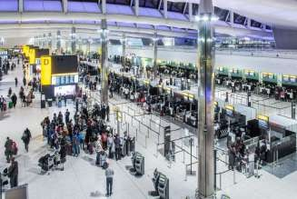
Concerns raised over possible Saudi majority ownership of Heathrow Airport
The Kingdom’s Public Investment Fund (PIF) and asset management firm Ardian recently inked a £2.4bn deal for a 25% stake from Spain based Ferrovial. Ardian is bacfied by PIF. Now, there is speculation other shareholders are close to selling their stakes to Saudi. The PIF has a huge war chest of assets worth over half a trillion pounds, with a big tourism portfolio. The prospect has worried some MPs. Former shadow
chancellor John McDonnell said: “Heathrow is a strategic resource and so I am naturally concerned about an asset like this.” Heathrow is in his Hayes and Harlington constituency. The concerns stem mostly from Saudi’s human rights record. Felix Jakens, head of campaigns at Amnesty International UK, said: “Companies must not get dazzled by the billions Saudi Arabia spends on sportswashing and other investments.” “Businesses must safeguard against any possible links to human rights violations.” The Saudis have spent heavily to establish a cruise tourism development agency and a new yet to launch airline, Riyadh Air with big ambitions. Heathrow declined to comment on the speculation. The Qatar Investment Authority also holds a stake in the Heathrow Airport parent company.

Surge in foreign tourists arrivals in India, to reach pre-covid by 2024
The foreign tourist arrivals (FTA) are likely to reach pre-pandemic level by 2024, Union Minister for Culture, Tourism and DoNER G. Kishan Reddy informed Lok Sabha on December 11. He made the statement based on data received from the Bureau of Immigration. Sharing the numbers from the last three years, the minister said the FTA provisional figures for 2023 stood at 6.43 million (from January till September), 1.52 million in 2021 and 6.43 million in 2022. The foreign exchange earnings from tourism jumped to INR 1,66,660 crore during Jan-Sept this year compared to INR 1,39,935 crore for the full year in 2022. The ministry, he informed, is promoting India as a holistic destination to increase the country’s share of the global tourism market. For the same, the government has drawn up an integrated marketing and promotional strategy and a synergised campaign in association with the travel trade, state governments and Indian Missions, he said. The government, he said, continuously engages with industry experts and other relevant stakeholders and takes their suggestions and feedback for promotion of varied tourism products of India. In order to boost visitor arrival, the Ministry of Tourism has declared “Incredible India! Visit India Year 2023", he added. Additionally, in order to increase the footfall of international tourists, the Ministry of Tourism participated in various international travel fairs in 2023, including FITUR 2023 in Madrid, ITB Berlin, Arabian Travel Market 2023 in Dubai, and IMEX in Frankfurt. The ministry also attended fairs in Japan, Singapore, London and Moscow to hardsell India as a tourist destination, he shared.

Singapore, China plan reciprocal 30-day visa-free entry
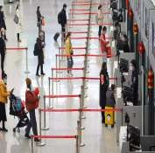
Singapore and China will put in place a 30-day mutual visa exemption agreement early next year, the Singapore foreign ministry said on Thursday. "Both countries will work out the implementation details of the mutual 30-day visa exemption arrangement and implement it in early 2024," the Singapore Ministry of Foreign Affairs said in a statement. Thailand and Malaysia also have exempted visas for Chinese tourists. Singapore Deputy Prime Minister Lawrence Wong, who is also Singapore's finance minister, is on a visit to Tianjin city and Beijing. Wong is co-chairing the 19th Joint
Council for Bilateral Cooperation (JCBC) in Tianjin. "The 30-day mutual visa exemption arrangement between our two countries will also support such progress, which can promote more personnel exchanges and strengthen the cornerstone of bilateral relations," the paper quoted him as saying.

Page 7

Issue #57
16-31st Dec‘23

Ayodhya's international airport reaches ﬁnal stages of construction 🔴IATA Code : AYJ 🔴ICAO Code : VEA
The Maryada Purushottam Shri Ram International Airport being built in Ayodhya, Uttar Pradesh, on the lines and outline of Ayodhya's Shri Ram temple has reached its final stages of construction. GM Airport Authority, Rajeev Kulshrestha, while speaking to the news agency, said that the airport work is in its final stages. He further said that the runway and parking are completely ready and the building work
is also in the final stage. "Beautification work is going on. The DGCA team has gone for an inspection. The flights will hopefully start soon. This entire airport is being built on the basis of the design of the temple of Lord Shri Ram and it is a matter of great pride for all of us that we are involved in the work of building this temple," said Rajeev Kulshrestha. Ayodhya District Magistrate, Nitish Kumar said that the airport has been inspected by the DGCA team and soon permission will be granted and people will be able to travel by flight to Ayodhya. "This is a pleasant experience for the residents of Ayodhya and the tourists coming from India and abroad. And there is good news as we hope that the Airport will be inaugurated soon and soon people will be able to avail the benefits of air travel," he said. Speaking about the design of the airport, one of the Architects of the Airport, Harsh Varshney, said, "The main spirit behind the airport is to bring back the magic and to regain the lost touch of Ayodhya, which has been an eternal city in itself. So an effort has been made to capture the lost spirit of Ayodhya and the famous design of this place and redo it in a building."

Etihad ﬂies to Bali from April next year
Etihad Airways will start flying non-stop to Bali, Indonesia from April 23, 2024. Flights will arrive at Ngurah Rai International Airport for passengers to make transfers to their destination.The airline will operate flights to Bali four times a week on Tuesdays,
Thursdays, Saturdays, and Sundays on its Boeing 787-9 Dreamliner.

Amadeus appoints Sandeep Dwivedi as Managing Director
Travel tech player Amadeus has appointed Sandeep Dwivedi as Managing Director – Travel Sellers, India and subcontinent, where he will oversee Amadeus’ commercial activities for travel sellers across the region, the company shared in an official release. Dwivedi takes over responsibilities for India and subcontinent from Ramona Bohwongprasert, SVP, Southeast Asia, Inside Sales & Startups, Travel Sellers, Asia
Pacific, Amadeus, who will continue to look after Southeast Asia with an expanded role of Inside Sales & Startups across the entire Asia Pacific region, it informed. Dwivedi brings with him decades of travel industry knowledge having held various senior leadership roles – most recent being for InterGlobe Technology Quotient where he played a pivotal role in driving growth across the Asia Pacific region.

Middle East’s premier half marathon sees new route & race come February
The 17th Ras Al Khaimah (RAK) Half Marathon will take place on February 24, 2024, and will boast a new route on Al Marjan Island as well as stage its first-ever 10km Road Race. The annual event, hosted by the Ras Al Khaimah Tourism Development Authority (RAKTDA), will feature many of the world’s elite long-distance athletes in the marquee 21.1km race with thousands of runners joining them either in the associated 10km or 2 km runs.
However, this will be the first time the RAK Half Marathon has offered a 10 km race.

Page 8

Issue #57
16-31st Dec‘23

Thai Vietjet commences services to Shanghai and Hangzhou
Expanding its wings to China, Thai Vietjet commenced 2 inaugural flights of its latest services from Bangfiofi to Shanghai and Hangzhou, as part of its response to the temporary tourist visa exemption scheme for passport holders of the People’s Republic of
China, which was recently announced by the Thai government. On 6 December 2023 at Shanghai Pudong International Airport and Hangzhou Xiaoshan International Airport, passengers travelling on the inaugural flight VZ3524 and VZ3536 from Bangkok Suvarnabhumi Airport were warmly welcomed upon their arrival in China, with special souvenirs from Thai Vietjet. “With the launch of two new services to Shanghai and Hangzhou, Thai Vietjet will further enhance the extensive connectivity between Thailand and China. As we are committed to offering more flying opportunities to our passengers, the new flight service will facilitate tourists travelling between Bangkok and China with comfortable service at affordable prices, we are proud to mark another great milestone today and will continue to elevate passenger experiences with more diversified services and products throughout the Asia-pacific region,” said Woranate Laprabang, Chief Executive Officer at Thai Vietjet. In the early stage of operations, the service between Bangkok and Shanghai will be operated with a daily flight frequency, while Bangkok – Hangzhou with four weeklies every Mon, Wed, Fri and Sunday.

SriLankan Airlines introduces double daily ﬂights to Mumbai
SriLanfian Airlines has introduced double daily flights between Colombo and Mumbai, multiplying the convenience for passengers travelling to and from India’s financial and entertainment capital. The new double daily service to Mumbai will not only give a 50 % boost to SriLankan’s capacity on its Mumbai route, but will
also strengthen the airline’s already vast network in India. Flights UL 142 and UL 144 will depart daily from Mumbai to Colombo at 3:10 hrs and 20:45 hrs, respectively. Flights UL 141 and UL 143 from Colombo to Mumbai will depart at 23:45 hrs and 17:10 hrs, respectively. Dimuthu Tennafioon, Head of Worldwide Sales and Distribution of SriLanfian Airlines, stated, “The Indian market has been incredibly important to SriLankan Airlines since the get-go, and with India fast becoming one of the world’s largest outbound travel markets, we are only happy to expand our operations in one of India’s most celebrated cities and make travel between Mumbai and Colombo extra seamless. Our frequency increase comes on the heels of Sri Lanfia announcing free visa for Indian visitors and we hope that these positive developments will encourage more travellers from Mumbai to stop by Sri Lanka.”
U.S. airlines expect a 16% increase in passengers this holiday season
More than 39 million people will travel on U.S. airlines over the two weeks surrounding Christmas and New Year Day, according to Airlines for America (A4A), an average of 2.8 million passengers per day. That's a 16% increase over the holiday season last year. Primary holiday surge to extend from Dec. 20 through Jan. 2. Last holiday season was marred by an unprecedented collapse by Southwest Airlines, which cancelled 16,700 flights between Dec. 21 and Dec. 31 after flights were initially disrupted by a massive winter storm system. Southwest says it's now more resilient, buoyed by investments in scheduling and crew assignment technology as well as by increased de-icing capacity and employee redundancy at key airports that deal with snow and ice. A4A says that airlines more generally have prepared for this year's holiday season by building industry staffing to the highest level in more than 20 years, investing in technology and adjusting schedules to prioritise operational performance.

Page 9

Issue #57
16-31st Dec‘23

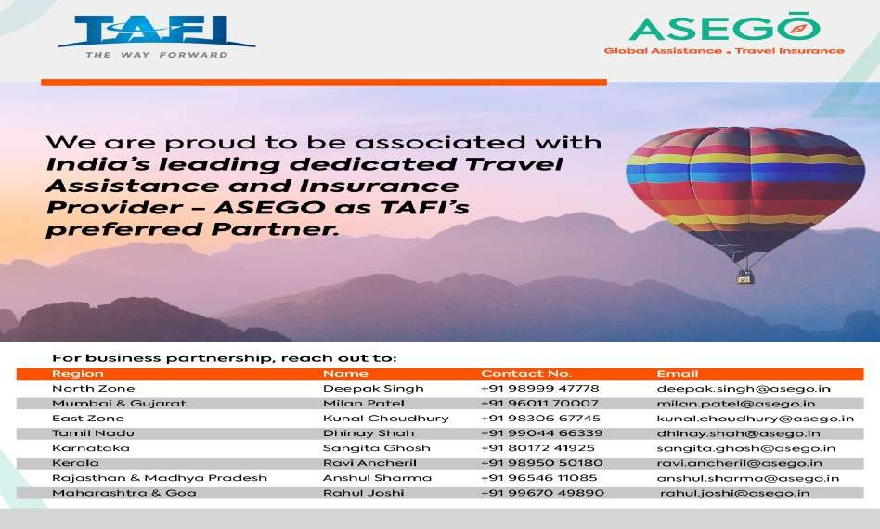

Airlines advised to self-regulate on airfares, keep passengers interest in mind: Scindia
The Civil Aviation Ministry has discussions with airlines over the airfares and these were advised to self-regulate and keep passengers' interest in mind while fixing the fares, Aviation Minister Jyotiraditya Scindia said on 7th Dec, asserting that the airfare is neither established nor regulated by the government. Scindia made the statement in response to a written question in the Lok Sabha about surge in airfares and steps taken by the government to address the issue. "As per prevailing regulations, airfare is neither established nor regulated by the government. The airline fare system runs in multiple levels (buckets or RBDs) which are in line with practice being followed globally."The fares are fixed by airlines keeping in mind the market, demand, seasonality and other market forces. The airfare increases with increase in demand for seats as the lower fare buckets get sold out faster and move to higher fare buckets," he said. Scindia informed that the Ministry had consultations with airlines and the representatives were advised to self-regulate and keep passengers' interest in mind while fixing the airfares. "Airlines have also been sensitised to exercise moderation in pricing, and to keep passenger interest in mind. The airlines have committed to ensuring that airfares do not surge during events such as natural disasters, calamities, etc," he said. The aviation minister said that airfares across various countries are dynamic in nature and follow the market principle of demand and supply. "The fares are also dependent on a number of other factors such as the number of seats already sold on a particular flight, prevailing fuel price, capacity of the aircraft operating on the route, competition on the sector, season, value of INR against US dollar, holidays, festivals, long weekends, events (sports, fairs, contests) etc. "Globally, most countries have deregulated their aviation sector--removing government-imposed entry and price restrictions on airlines. Deregulation has led to increased competition between airline carriers, leading to decrease in airfare. "As a result of deregulation, entry into the airlines industry for a potential new airline has become easier, resulting in many new airlines entering the market, thus increasing competition," Scindia said..

Page 10

Issue #57
16-31st Dec‘23

CSMIA records highest-ever monthly passenger traﬃc, single-day traﬃc
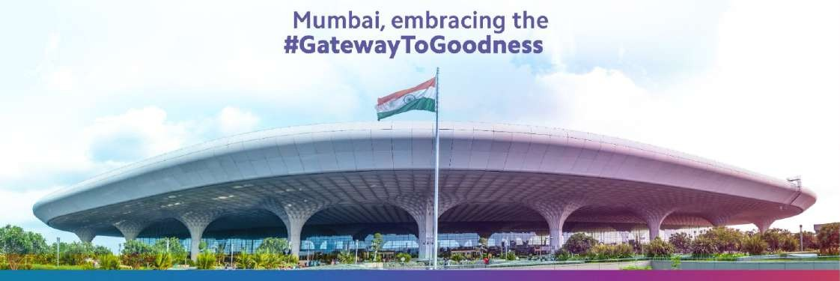
Chatrpati Shivaji Maharaj International Airport (CSMIA) recorded 109% recovery in November passenger traffic compared to the pre-pandemic levels of November 2018 with 4.46 million passengers travelling through the airport. Additionally, the airport recorded the highest passenger traffic movement in a single day for the month on November 25 with 167,132 passengers travelling through CSMIA (with more than 1,20,000 domestic pax movements and more than 46,000 international pax movements). In another record, on November 11, CSMIA achieved its highest-ever single-day Air Traffic Movements (ATMs) with a total of 1,032 ATMs, shared CSMIA.Additionally, the airport experienced its highest-ever monthly traffic in November 2023, reaching a substantial 4.46 million, with a growth of 13% as compared to November 2022 (3.9 million). With regard to domestic traffic, a staggering 3 million passengers travelled through CSMIA during the month. November ’23 also witnessed a total of 28,679 ATMs, a 12% growth compared to November 2022 (25,375). CSMIA recently expanded its international connectivity and frequency with services to destinations such as Entebbe, Baku, Bangkok, and Toronto adding to the diverse travel network.

IndiGo to operate ﬁrst ﬂight out of Ayodhya from January 6
IndiGo has announced Ayodhya in Uttar Pradesh as its 86th domestic and 118th overall destination in their 6E network as the airline is all set to commence operations from the holy city. IndiGo is also going to be the first airline to operate flights from the soon-to-be-opened Maryada Purushottam Shri Ram International Airport in Ayodhya. The first flight from Delhi will arrive in Ayodhya on December 30, 2023. Thereafter, direct commercial flights between Delhi and Ayodhya will commence from January 06, 2024, followed by tri-weefily flights between Ahmedabad and Ayodhya from January 11, 2024. With the inauguration of the Ram Mandir in Ayodhya scheduled for January 2024, the city is expected to witness a significant surge in travel activity. These new flights will provide pilgrims direct access to Ayodhya from Delhi and Ahmedabad and further across the 6E network across India and overseas. Vinay Malhotra, Head of Global Sales, IndiGo said, "We are delighted to announce the launch of operations from IndiGo's 86th domestic destination, Ayodhya. The new flights connecting Delhi-Ayodhya and AhmedabadAyodhya will bring Ayodhya on the country’s aviation map. Given Ayodhya’s historical and cultural significance, our new flights will provide ease of access to the city for pilgrims as well as other tourists. As India’s leading carrier.” Ayodhya holds tremendous historical and cultural importance in India. For centuries, it has been a cornerstone of religious devotion, as it is the sacred birthplace of Lord Rama.

Page 11

